UNIT 5

Q1) What is Mobile-First and Mobile Web? List different Mobile Devices.  
**Mobile-First**

Mobile-First is a web design and development approach that prioritizes the creation of a website or application's design and user experience for mobile devices (smartphones, tablets) before considering desktop or larger screens. The philosophy is based on the increasing prevalence of mobile internet usage. By starting with the constraints of smaller screens and mobile contexts (like touch interfaces and potentially slower connections), designers and developers are encouraged to focus on essential content and functionality, resulting in a cleaner, more efficient, and better-performing experience that can then be progressively enhanced for larger screens. This contrasts with the traditional approach of designing for desktop first and then scaling down (which often leads to a compromised mobile experience).

**Mobile Web**

The Mobile Web refers to accessing the World Wide Web using mobile devices like smartphones and feature phones. It encompasses websites and web-based services designed to be viewed and interacted with through mobile browsers over a wireless network. The mobile web experience is influenced by factors such as screen size, touch input, and network speed, leading to the development of mobile-optimized websites and responsive design to ensure usability on a variety of mobile devices.

**Different Mobile Devices**  
**Smartphones:** Handheld devices that combine cellular and mobile computing functions, offering advanced features, internet connectivity, and the ability to run a wide variety of applications (e.g., iPhones, Android phones).  
**Tablets:** Portable computers with touchscreen interfaces, larger than smartphones but smaller than laptops, often used for Browse, media consumption, and light productivity (e.g., iPads, Android tablets).  
**Feature Phones:** Mobile phones that offer basic functions like calling, texting, and simple internet Browse, but lack the advanced computing capabilities of smartphones.  
**Smartwatches:** Wearable devices worn on the wrist that provide features like notifications, fitness tracking, and in some cases, limited internet connectivity and app support.  
**Portable Media Players:** Devices designed primarily for playing audio and video files (though many modern smartphones and tablets have made these less common).  
**Handheld Gaming Consoles:** Portable electronic devices designed specifically for playing video games.  
**E-readers:** Devices optimized for reading digital books and documents.  
**Portable Navigation Devices (GPS devices):** Devices primarily used for navigation and mapping.  
---------------------------------------------------------------------------------------------------------------------------------------------------------------------------  
Q2) Explain the concept of Mobile-First design in web development. Explain its significance and benefits in creating responsive and user-friendly websites.   
**What is Mobile-First Design?**  
Instead of designing a website for desktops and then adapting it for smaller screens (which was the traditional method), **Mobile-First** flips the process. The design starts with the mobile experience—focusing on touch-friendly navigation, minimalistic layouts, and optimized performance—then expands to larger screens using progressive enhancement techniques.

**Significance of Mobile-First Design**  
1. **Mobile Dominance** – With smartphones being the primary browsing device for millions, ensuring a smooth mobile experience is essential.  
2. **Better User Experience (UX)** – Mobile-first design forces developers to simplify content, improve navigation, and prioritize key features for a streamlined UX.  
3. **SEO & Ranking Advantage** – Search engines like Google favor mobile-friendly websites, boosting their rankings in search results.  
4. **Adaptability Across Devices** – A mobile-optimized site ensures consistent functionality when accessed on various devices, including tablets and desktops.  
5. **Faster Loading Speeds** – Mobile-first designs often eliminate unnecessary elements, leading to faster page loading times and better performance.

**Benefits of Mobile-First Design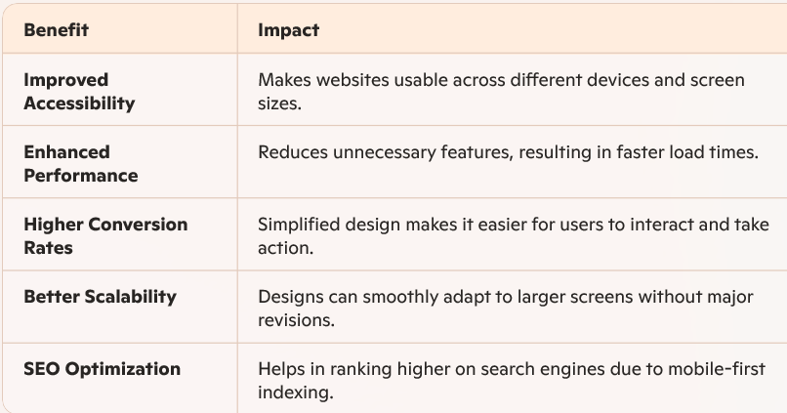 Key Principles of Mobile-First Design**  
**Prioritize Core Content** – Display essential content first; avoid clutter.  
**Responsive Design** – Use flexible layouts and scalable elements to adapt across devices.  
**Touch-Friendly Navigation** – Ensure buttons, menus, and links are easy to tap.  
**Optimized Images & Assets** – Compress media files to improve performance.  
**Progressive Enhancement** – Start with a basic mobile layout, then add advanced features for larger screens.  
---------------------------------------------------------------------------------------------------------------------------------------------------------------------------  
Q3)  **What is jQuery mobile?**jQuery Mobile is a unified user interface (UI) system designed for all popular mobile device platforms. It is built upon the core jQuery library and the jQuery UI foundation. It's also known as a mobile framework, specifically an open-source, cross-platform framework.jQuery Mobile provides UI widgets that are specifically designed to be touch-friendly for mobile devices. It also includes a powerful theming framework that allows you to style your mobile application. A key benefit highlighted is its "write code once" principle, meaning the same codebase can work seamlessly across different mobile operating systems like Android, iPhone, and iPad, as well as on web browsers such as Google Chrome, Mozilla Firefox, and Safari on your desktop.

**Is jQuery mobile framework? If yes, explain it in brief.**  
Yes, jQuery Mobile is a mobile framework. As mentioned in the definition, it is an open-source, cross-platform framework built on the jQuery and jQuery UI libraries, providing a structured system for developing mobile web applications.

**features of jQuery mobile?**  
The features of jQuery Mobile include:  
**Accessibility:** It is used to develop for cross-platform, cross-device, and cross-browser compatibility, making websites or web applications easily accessible from any device.  
**Lightweight size:** jQuery Mobile is noted for its lightweight size, which is approximately 40 KB when minified.  
**Responsiveness:** The framework's full responsiveness allows the same underlying codebase to adapt comfortably to different screen sizes, from mobile devices to desktop-sized screens.  
**Progressive enhancement and graceful degradation:** It utilizes progressive enhancement, a technique that provides a basic level of compatibility for all users (accessing core content and functionality) while offering an enhanced experience for browsers that support more advanced features and standards. jQuery Mobile is designed to be totally built using this technique.  
**Theming and UI widgets:** jQuery Mobile has an in-built theme system that enables developers to determine their application's styling. The Theme Roller tool allows developers to effectively customize the look and feel to match their desired color schemes and preferences.  
**Great simplicity and usability:** The framework is described as being easy and flexible to use.

**Advantages and Disadvantages of jQuery Mobile:**  
**Advantages:**  
**Easy to learn:** It is easy to learn, especially if you are already familiar with HTML, CSS, and JavaScript.  
**Large library:** It has a large library that enables you to perform complex functions compared to just using plain JavaScript.  
**Cross-platform framework:** Being a cross-platform framework means you don't need to write different code for various device resolutions; a single codebase works for multiple devices and platforms.  
**Open-source community:** It has an open-source community where you can find various jQuery plugins to implement in your projects.

**Disadvantages:**  
**Limited functionality:** It offers limited functionality compared to native mobile application development.  
**Limited visual design customization:** There are limited options for customizing the visual design.  
**Limited CSS themes:** The options for CSS themes are limited.  
**Slower application speed on mobile devices:** Applications built with jQuery Mobile can be slower on mobile devices.  
---------------------------------------------------------------------------------------------------------------------------------------------------------------------------  
Q4) **What is jQuery Mobile? Explain Mobile jQuery Framework in detail.**

jQuery Mobile is an open-source, cross-platform mobile framework built on the solid foundations of the jQuery and jQuery UI libraries. Its primary goal is to provide a unified user interface system that works across all popular mobile device platforms, as well as on desktop browsers. Essentially, it's a high-level framework that simplifies the process of building mobile-friendly websites and web applications.

Here's a detailed breakdown of jQuery Mobile as a framework:  
**Built on jQuery Core and jQuery UI:** jQuery Mobile leverages the power and familiarity of the jQuery library for DOM manipulation, event handling, and AJAX interactions. It also builds upon the jQuery UI foundation, which provides a set of widgets and theming capabilities. This makes it relatively easy for developers already familiar with jQuery to pick up and use jQuery Mobile.  
**Unified UI System:** One of the core tenets of jQuery Mobile is to offer a consistent look and feel across a wide range of mobile operating systems and devices. It provides a set of pre-built, touch-friendly UI widgets and page structures that are designed to adapt to different screen sizes and orientations. This "write less, do more" philosophy extends to building user interfaces that behave predictably regardless of the underlying device.  
**Cross-Platform and Cross-Browser:** jQuery Mobile is designed to work seamlessly across various mobile platforms (Android, iOS, Windows Phone, etc.) and major desktop browsers. This eliminates the need for developers to write platform-specific code, significantly reducing development time and effort.  
**Mobile-First and Responsive Design Principles:** While the term "Mobile-First" became more prominent later, jQuery Mobile inherently supports principles of building for smaller screens first. Its responsive design capabilities allow the layout and content to automatically adjust to fit different screen dimensions, providing a comfortable viewing experience on a wide range of devices, from small smartphones to larger tablets and desktops. It also aligns with the concept of progressive enhancement, providing a functional base experience on less capable browsers while offering enhanced features on more modern ones.  
**Touch-Friendly UI Widgets:** The framework provides a collection of UI widgets specifically optimized for touch interaction. These include elements like:   
 Pages and dialogs for structuring content.  
 Toolbars (headers and footers) for navigation and actions.  
 Lists for displaying data.  
 Buttons and form elements designed for easy tapping.  
 Panels for creating side menus.  
**Theming Framework:** jQuery Mobile includes a powerful and flexible theming system. It offers a default theme that provides a native look and feel, and it also allows for extensive customization. The Theme Roller tool is a key part of this, enabling developers to visually design and download custom themes without having to write complex CSS from scratch. This helps in branding and creating a unique look for applications.  
**AJAX Navigation and Page Transitions:** The framework utilizes AJAX to load and transition between pages. This provides a smoother and faster navigation experience for users, similar to native mobile applications, by avoiding full page reloads.  
**Simplified Development:** By providing pre-built components, automatic responsiveness, and a unified API, jQuery Mobile simplifies the process of building mobile web applications. Developers can focus more on the application's logic and content rather than wrestling with device-specific compatibility issues.  
---------------------------------------------------------------------------------------------------------------------------------------------------------------------------

Q5)  
---------------------------------------------------------------------------------------------------------------------------------------------------------------------------  
Q6) Write a code to create a header and footer in jQuery mobile.   
Header and Footer for a page is used to design for special content of a web app such as in header we may have the title of a page or content title and navigation where in footer we can have copyright content, sitemap.   
The header text content will be in h1 tag and footer text content will be in h4 tag.   
The header divided into three subareas: left, title, and right where in left and right area we can place buttons and in title we can set the title of a page.   
The footer is optional

•The necessary HTML5 doctype and meta tags.

• Links to the jQuery and jQuery Mobile CSS and JavaScript files (using CDN links for simplicity).

• A div with data-role="page" to define a jQuery Mobile page.

• A div with data-role="header" for the header, including a page title.

• A div with data-role="main" for the main content area.

• An optional div with data-role="footer" for the footer, including some footer text.

**Explanation:**  
**data-role="page":** This attribute is essential for jQuery Mobile to recognize and style the content as a mobile page.  
**data-role="header":** This attribute designates the div as the header for the page. jQuery Mobile automatically applies the appropriate styling for a header bar. The content within the header is typically a heading (like <h1>) for the page title. You can also add buttons here by placing <a> or <button> elements within the header div and often wrapping them in divs with classes like ui-btn-left or ui-btn-right for positioning (though jQuery Mobile's grid system or custom CSS can also be used for more complex layouts).  
**data-role="main":** This div contains the primary content of your page. The ui-content class is commonly used for padding and consistent styling within the content area.  
**data-role="footer":** This attribute designates the div as the footer for the page. Similar to the header, jQuery Mobile styles it as a footer bar. Footers often contain copyright information, sitemaps, or other less critical navigation links. As the image mentioned, the footer is optional.  
**<h1> and <h4>:** The image suggests using <h1> for the header text and <h4> for the footer text. While you can use other heading tags or paragraph tags, using semantic heading tags is generally good practice for document structure. jQuery Mobile styles these elements within the header and footer accordingly.

To use this code, save it as an HTML file (e.g., index.html) and open it in a web browser, preferably on a mobile device simulator or an actual mobile device, to see how jQuery Mobile renders the header and footer. Remember to ensure you have an internet connection to load the jQuery Mobile library files from the CDN links.  
---------------------------------------------------------------------------------------------------------------------------------------------------------------------------  
Q7) jQuery Mobile provides a set of custom events that are particularly useful for handling interactions on mobile devices and managing the lifecycle of its pages. Here's an explanation of three such events with examples:

**Important Note:** In jQuery Mobile, it's recommended to use page events like pagecreate or pageinit to bind event handlers for elements within a page, rather than the traditional $(document).ready(). This is because jQuery Mobile loads pages via AJAX, and $(document).ready() only fires for the initial page load. pagecreate fires after a page is added to the DOM but before enhancements, while pageinit fires after a page has been initialized and enhanced. pageinit is generally preferred for manipulating enhanced markup. We will use pagecontainercreate bound to the document, which is a reliable way to target elements within pages as they are created.

Here are three jQuery Mobile events:

**1. tap Event**  
**Description:** The tap event is a custom jQuery Mobile touch event that triggers after a quick, complete touch event on an element. It's the touch equivalent of a standard click event but is optimized for touchscreens.  
**Example:** Hiding an element when it is tapped.

**2. swipeleft Event**  
**Description:** The swipeleft event is a custom jQuery Mobile touch event that triggers when a user horizontally drags their finger (or mouse) across an element by a certain distance (default is 30px) in the left direction within a specific time duration (default is 1 second).  
**Example:** Displaying an alert when an element is swiped left.

**3. pageshow Event**  
**Description:** The pageshow event is a jQuery Mobile page event that triggers on the "toPage" (the page being transitioned to) after the transition animation has completed. This event is useful for executing code that should run every time a specific page is fully visible to the user.  
**Example:** Displaying a message in the console when a specific page is shown.

These examples demonstrate how to bind to and use three different types of events in jQuery Mobile: a touch event (tap, swipeleft) and a page lifecycle event (pageshow). jQuery Mobile offers many other events for various interactions and page states, providing developers with fine-grained control over their mobile web applications.  
---------------------------------------------------------------------------------------------------------------------------------------------------------------------------  
Q8) Q.30 List any five CSS classes for jQuery mobile.

jQuery Mobile framework uses different classes to design web app.

These classes are applied to HTML elements / tags. Some of the classes are listed below:

oui-corner-all - To make elements in with rounded corners

o ui-shadow - To display shadow of elements

o ui-overlay-shadow - To display overlay shadow of elements

oui-mini- To make elements smaller

oui-btn- It shows element as button style

o ui-icon-ICONNAME - It will show icon (ICONNAME will be different)

oui-bar-(a-z) It shows the color bars such as header footer among a-z

oui-body-(a-z) - It shows the color body with a-z value

oui-grid-solo-It

--------------------------------------------------------------------------------------------------------------------------------------------------------------------------  
**Q5 b) What is jQuery Mobile? Explain layout in jQuery Mobile design with its types.**

**Answer:**

**jQuery Mobile** is a framework built on top of jQuery that helps create responsive, touch-friendly web applications that work across all popular smartphones, tablets, and desktops.

**Layouts in jQuery Mobile** refer to structured containers like pages, headers, footers, and content areas.

**Types of Layouts:**

1. **Single-page layout:** Only one page (one data-role="page") in an HTML file.
2. **Multi-page layout:** Multiple data-role="page" blocks in a single HTML file.
3. **External page layout:** Pages loaded from external HTML files via Ajax.
4. **Fixed toolbar layout:** Fixed headers/footers using data-position="fixed".

Each layout uses data-role attributes to define its role (page, header, footer, etc.).

jQuery Mobile provides a simple grid system to create responsive layouts using a series of rows and columns. You apply the grid system by adding specific classes to container div elements.

The main container div gets a class based on the number of columns you want in that row. Inside this container, you add child div elements, each representing a column or "block", and assign them a corresponding block class.

**jQuery Mobile Grid:**

It includes ui-grid-solo class to create single grid in div with 100 % width.

And if you want to use two column, three column, four column, five column grid system use class ui-grid-a, ui-grid-b, ui-grid-c, ui-grid-d respectively.

Within these classes use child div classes as ui-block-a, ui-block-b, ui-block-c, ui-block-d.

**Q6 a) Why is CSS important in designing mobile websites? Give an example of CSS class used for mobile website design.**

**Answer:**

**CSS (Cascading Style Sheets)** is essential for designing mobile websites because:

* It enables responsive layouts for various screen sizes.
* It enhances UI aesthetics.
* It helps in consistent styling and faster load times.
* It supports theming and customization.

**Example CSS Classes in jQuery Mobile:**

* .ui-btn – Styles buttons
* .ui-header – Styles the page header
* .ui-content – Styles the content area
* .ui-footer – Styles the footer

**Example:**

<a href="#" class="ui-btn ui-btn-b">Click Me</a>

Here, ui-btn-b applies a specific theme style.

**Q6 b) List any five widgets in jQuery Mobile and explain any two in brief.**

**Answer:**

**Five jQuery Mobile Widgets:**

1. Button (<a> or <button> with ui-btn)
2. Slider (<input type="range">)
3. Collapsible (<div data-role="collapsible">)
4. Dialog (data-rel="dialog")
5. Listview (<ul data-role="listview">)

**Explanation of Two:**

**1. Slider:**  
Used for numeric input. It allows users to select a value using a handle.

<input type="range" name="volume" min="0" max="100" value="50">

**2. Collapsible:**  
Creates expandable/collapsible panels.

<div data-role="collapsible">

<h4>More Info</h4>

<p>This content can be hidden or shown.</p>

</div>  
-------------------------------------------------------------------------------------------------------------------------------------------------------------------------------  
**What is Navigation in jQuery Mobile?**

**Navigation** in jQuery Mobile refers to the process of moving between different views or "pages" in a mobile web application. jQuery Mobile supports both **single-page** and **multi-page** navigation using AJAX and hash-based URLs, enabling smooth transitions and a native-app-like experience.

There are **two main types of navigation**:

1. **Internal Navigation** – Navigating between multiple div blocks with data-role="page" in the same HTML file.
2. **External Navigation** – Navigating between different HTML files.

Navigation in jQuery Mobile uses standard anchor (<a>) tags and the framework automatically handles transitions, history, and page loading via AJAX.

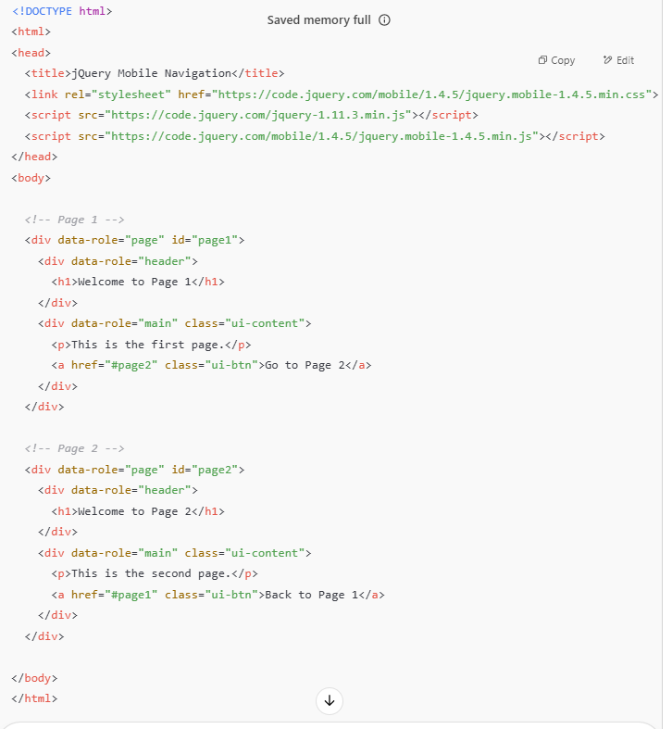  
**Explanation of Code:**

* data-role="page": Marks each "virtual page" inside the single HTML file.
* href="#page2": jQuery Mobile navigates to the element with that ID using AJAX.
* class="ui-btn": Applies jQuery Mobile’s styled button.
* The framework manages **history**, **transitions**, and **hash-based URLs** automatically.